**3D Boho Bull Head Skull**

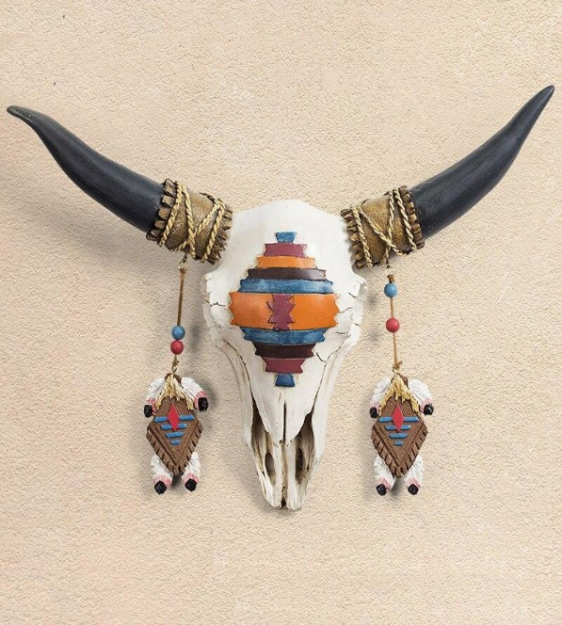A 3D boho bull head skull is a captivating decor piece that blends rustic charm with bohemian flair, perfect for adding character to any space. Designed with intricate detailing, the bull skull often features carved patterns, floral motifs, or geometric accents that reflect boho aesthetics. Made from materials like resin, wood, or metal, its natural or whitewashed finish is sometimes enhanced with pops of color, feathers, or beads for a more eclectic look. This artistic wall mount embodies free-spirited and earthy vibes, making it an ideal centrepiece for boho, farmhouse, or eclectic interiors, evoking a sense of wild beauty and individuality.